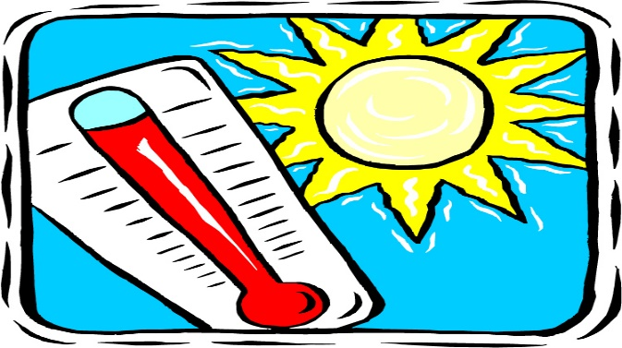

**Outdoor Heat Safety**

**Drinking water is important to reduce the risk of heat illness. While doing heavy work in high heat conditions, the human body loses up to two gallons of water per day. You need to consume about three - four cups of water every hour starting at the beginning of your work shift and throughout the day.**

**Rest breaks allow your body to recover from work in the heat. A rest break in the shade for at least five minutes can reduce your heat stress and prevent heat illness. Use rest breaks to recover from hard work in the sun before any heat illness symptoms appear.**

**It’s better to beat the heat than treat the heat illness. Take rest breaks in a shaded area before your symptoms appear and drink plenty of water while working in the heat.**

**If working outdoors regularly, lower your risk for any heat illness and stay safe outdoors with these tips:**

* Avoid strenuous physical activity.
* Drink plenty of water, even if you are not thirsty.
* Stay in the shade and out of direct sun.
* Wear light, loose-fitting clothes.
* Put a hat on to protect your face and head.
* Use sunscreen with SPF 15 or higher.
* Limit outdoor activities to early morning and late evening hours.
* Avoid drinks with alcohol, caffeine or sugar.
* Drink water every 15 minutes.
* Take frequent rest breaks in shaded or air-conditioned areas.
* Wear lightweight, light colored, loose-fitting clothing if possible.
* Be alert for the signs of heat illness in yourself and in your colleagues.

**Lawn mower safety tips**

1. Check conditions. You can start mowing only when the conditions are safe. (See outdoor heat safety.)
2. Beware of burns. Engine and exhaust can become extremely hot. If repairing the lawn mower, make sure it’s in the off position and cooled down.
3. Read your mower's instruction manual prior to use.
4. Keep your mower in good working order with sharp blades. Only use a mower that has protection over hot and sharp parts.
5. Pick up potential flying objects, such as stones, toys and debris, before you start mowing.
6. Wear goggles, hearing protection, gloves and long pants. Always wear sturdy close-toed shoes while mowing the lawn.
7. Do not remove safety devices or guards on switches.
8. Never insert hands or feet into the mower to remove grass or debris. Even with the motor turned off, the blade can still be spinning. Use a stick or broom handle instead. The machine must be turned off and the spark plug disconnected (or power cord unplugged for electric models) before attempting to remove the object.  The machine will likely still have one “turn” remaining in the motor/gears even after the power is disconnected, and the blades/rotors will turn forcefully once the obstruction is cleared. DO NOT assume that you are safe just because the power switch is off.
9. Never lift a mower by the bottom for transport; the blades can cut fingers even if they are not moving. When being moved or picked up, the lawn mower should be turned off, spark plug disconnected, and unplugged.
10. Never cut grass when it is wet or damp.
11. Do not pull a mower backward or ride it in reverse unless necessary.

  